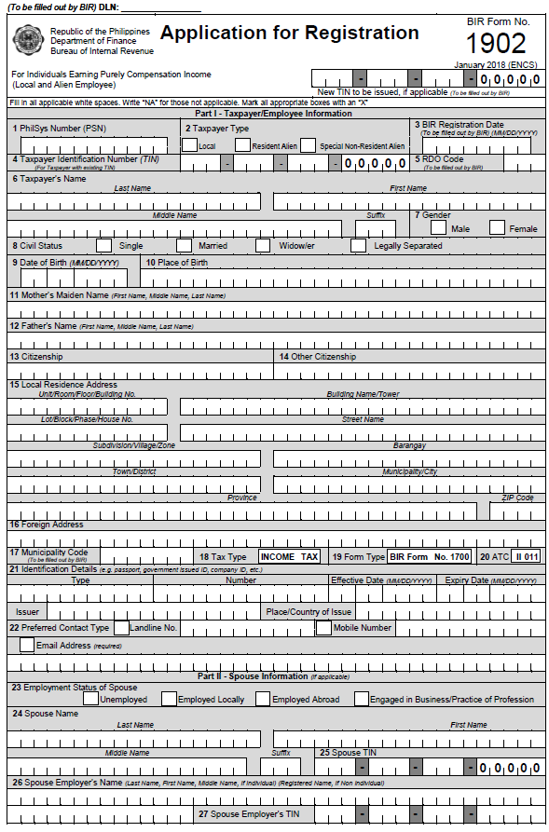

**F I L I P I N O**

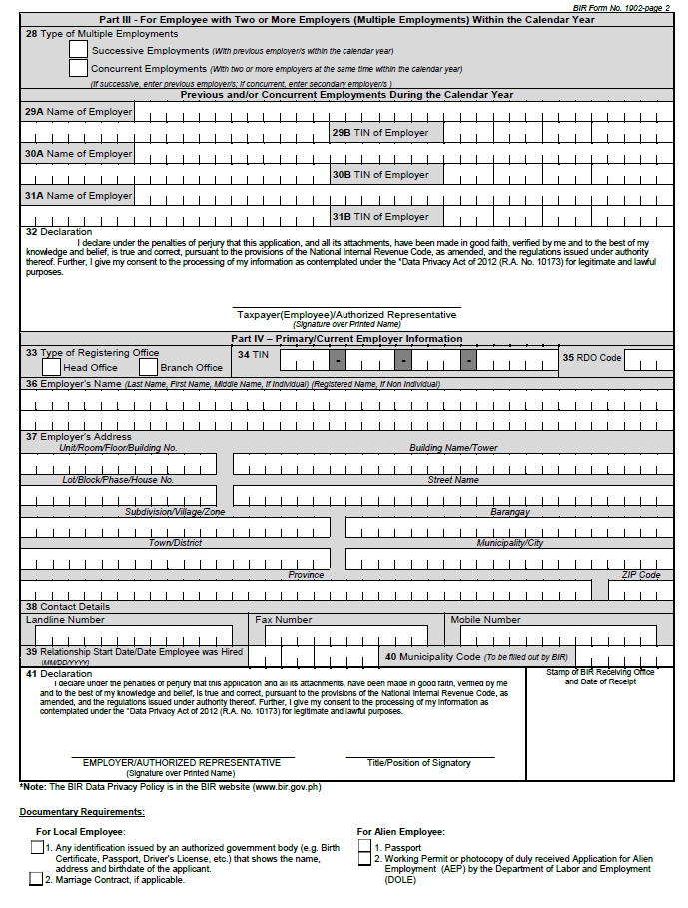

**ATTY. GIL S. MUNCADA**

**P r o v I n c i a l C a p i t o l**

**P r o v I n c i a l G o v e r n m e n t o f Z a m b o a n g a d e l N o r t e**

**0 0 0 5 6 0 9 0 2**

**7 1 0 0**

**Z a m b o a n g a d e l N o r t e**

**D i p o l o g C I t y**

**E s t a k a**

**G e n e r a l L u n a S t r e e t**

**OIC-Prov’l. Human Resource Magt. Officer**